Utility Billing ACH Authorization Form

Please print and complete ALL the information below.

Account Number: ____________________________________________________________

Name: ____________________________________________________________

Address: ____________________________________________________________

City, State, Zip: ____________________________________________________________

Email and Phone: ____________________________________________________________

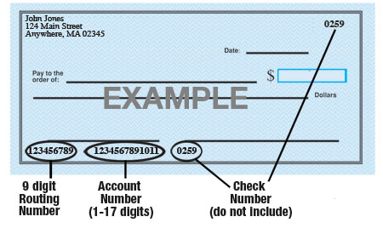

Name of Bank: ____________________________________________________________

Account #: ____________________________________________________________

9-Digit Routing #: ____________________________________________________________

Type of Account: ◻ Checking ◻ Savings (Check One)

Village of Metamora is hereby authorized to withdraw my total utility bill on the 15th of every month (or next business day) from the account listed above. This authorization will remain in effect until I modify or cancel it in writing.

Signature: ______________________________________________________

Date: ___________________________

